Quabo Firmware Release v005

Feb 14, 2019
In addition to what was done below for v004, made the "board_loc" value (reported in the science and housekeeping packets) dependent on the jumper setting: 0x1234 for jumper installed, 0x1235 for jumper removed.

Feb 7, 2019: v004:
Added a jumper-selectable IP address. One pair of pins of the J3 header is used for this:
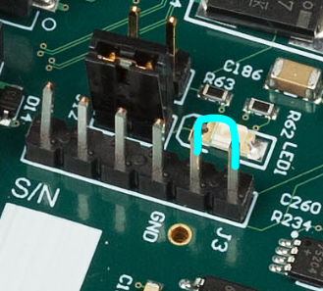
The Quabo will have the following IP address:
Jumper installed: 192.168.1.10
Jumper removed: 192.168.1.11
Remember to change the IP address in the controlling software accordingly.

Note that the jumper is checked only at boot-up; if you change the jumper you need to cycle power for the change to take effect.

Testpoints are now:
J3 pin
1 IP Sel jumper
2 IP Sel jumper
3 Stim sync- a signal in sync with the Stim generator
4 ph_trigger- this is the OR of all the masked triggers, synced to the 200MHz clock (a channel whose trigger_mask bit is set will not cause a pulse here. This is the signal which starts up PH mode data acquisition)
5 cc_fifo_full- the full signal from the PH clock-crossing FIFO
6 image_tready- signal indicating that IM mode channel is ready to accept data
Pins 3 and 4 may be useful for exploring trigger function.

